Pokhara University

Level: Bachelor | Semester – Spring | Year : 2005
Programme: BE |  | Full Marks : 100
Course: Object Oriented Programming in C++ |  | Time : 3hrs.

Candidates are required to give their answers in their own words as far as practicable.
The figures in the margin indicate full marks.

Attempt all the questions.

1. | - Describe object oriented programming as a new paradigm. What are the unique advantages of it?  - Explain state, behaviour and identity in light of object-oriented paradigm. | 7  8
2. | - Define classes and objects? How does a class accomplish data encapsulation?  - What do you mean by memory recovery? Explain the term stack versus heap storage allocation. | 8  7
3. | - Explain the purpose of constructor and destructor. Describe their significances. Can we have more than one destructor in a class? Explain it.  - Create a class called Student with six data members (rollno, name, marks in english, maths, and science, total), a constructor that initialises the data members to the values passed to it as parameters, a function called calctotal() that calculates the total of the marks obtained in the three subjects, and a function called display() that displays the details of the student.  In main, create two objects of the class Student and for each object call the calctotal() and the display() functions. | 7  8
4. | - What does inheritance mean in C++? Describe the syntax of the single and multiple inheritances. When do we use the protected visibility specifier to a class member?  - An Education institute wishes to maintain a database of its employees. The database is divided into a number of classes whose hierarchical relationships are shown in figure. The figure also shows the minimum information required for each class. Specify all the classes and define functions to create the database and retrieve individual information as an when required.  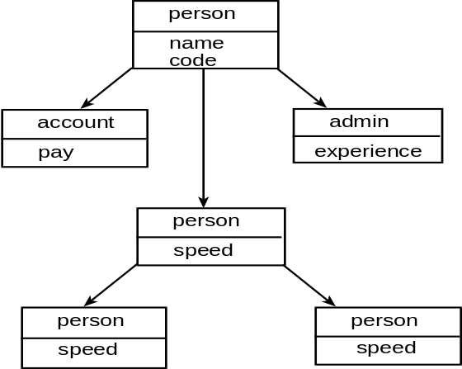 | 6  9
5. | - What is a pure virtual function? What implications it applies when a function is declared as pure virtual function? Give an example.  - What is operator overloading? Why is it necessary to overload an operator? Explain with suitable example. | 2+2+4  7
6. | - What is containership? How does it differ from inheritance?  - Why type casting is important in OOP? Define two classes Time12 and Time24 that represents time in 12 hour and 24 hour format respectively. Write a conversion routine to convert time from one format to another. | 5  2+8
7. | Write short notes on (Any Two):  - new and delete operator  - Templates  - Static Data members  - this printer | 2x5

